## FITFLEX: YOUR VIRTU ****Known Issues (Potential Challenges)****

* Accuracy of calorie/nutrition tracking (depends on user input).
* Integration issues with third-party wearables/APIs.
* Internet dependency for cloud sync.
* Data privacy concerns (requires strong security).
* Motivation drop-off if users don’t engage consistently

**AL FITNESS COMPANION**

**INTRODUCTION:**

FITFLEX is an intelligent and personalized fitness companion designed to guide users in achieving their health and wellness goals. Whether you’re a beginner starting your fitness journey or an experienced athlete aiming to optimize performance, FITFLEX provides tailored solutions to keep you motivated and consistent.

With its user-friendly design, smart workout tracking, and adaptive recommendations, FITFLEX helps you maintain balance across **exercise, nutrition, and lifestyle habits**. The app acts as your **virtual trainer, nutrition advisor, and progress monitor**, ensuring that fitness becomes not just a goal, but a sustainable lifestyle.

**PROJECT TITLE: FITFLEX:YOUR FITNESS COMPANION**

**Team Members:**

* **TEAM LEADER: ANBUSELVAN**
* **SATHYA S**
* **THENMALAR M**
* **SUGANYA S**

**PROJECT OVERVIEW:**

FITFLEX is a **smart fitness companion application** designed to promote healthy living by integrating **personalized workout routines, nutrition guidance, and progress tracking** into one unified platform. The project aims to bridge the gap between professional fitness coaching and user accessibility, making wellness achievable for everyone.

The application adapts to user needs by analyzing preferences, fitness levels, and lifestyle habits. With AI-driven recommendations, FITFLEX provides **customized workout plans, meal suggestions, motivational insights, and community engagement** to keep users consistent on their fitness journey.

**Objectives**

* Provide **personalized fitness guidance** through adaptive workout and diet plans.
* Enable **real-time tracking** of activities, calories, and progress.
* Offer **goal-oriented features** such as weight management, muscle gain, endurance, or overall wellness.

**ARCHITECTURE:**

FITFLEX follows a **modular client-server architecture** with seamless integration of third-party services (wearables, health APIs).

* **Frontend (Mobile/Web App)**
  + Built with **React Native / Flutter** (for cross-platform mobile support).
  + **React.js** for the web application.
  + Responsive UI with smooth navigation.
* **Backend**
  + RESTful APIs with **Node.js / Express.js**.
  + Microservices architecture for scalability.
  + Secure authentication (JWT / OAuth2).
* **Database**
  + **MongoDB** for user data, workouts, and nutrition tracking.
  + **PostgreSQL** for structured fitness program data.
* **Integration Layer**
  + APIs for fitness wearables (Google Fit, Apple Health, Fitbit).
  + Payment gateway for premium subscriptions.
* **Cloud & Hosting**
  + Hosted on **AWS / Firebase** for reliability and scalability.
  + Cloud storage for media (progress photos, workout videos).

## ****2. Component Structure****

* **Authentication Module**
  + Sign-up, login, password reset, social login.
* **User Profile & Onboarding**
  + Fitness assessment (age, gender, goals, health conditions).
  + Personalized fitness level setup.
* **Workout Module**
  + AI-based workout recommendations.
  + Exercise library with videos & instructions.
  + Workout scheduler & reminders.
* **Nutrition Module**
  + Daily calorie & macro tracking.
  + Meal recommendations.
  + Food database integration.
* **Progress Tracking & Dashboard**
  + Weight, BMI, calories, activity graphs.
  + Weekly/monthly reports.
* **Community & Social Features**
  + Challenges, leaderboards.
  + Share achievements.
  + Group discussions.
* **Settings & Notifications**
  + Push notifications for reminders.
  + Custom preferences.

## ****3. State Management****

* **Frontend**
  + Uses **Redux / Zustand** (React) or **Provider/Bloc** (Flutter).
  + Centralized store for user data, workouts, and nutrition logs.
* **Backend**
  + State consistency ensured with caching (Redis).
  + Event-driven updates for real-time sync.

## ****4. Routing****

* **Frontend Routing**
  + **React Router (Web)** / **React Navigation (Mobile)**.
  + Key routes:
    - /login – User Authentication
    - /dashboard – User Home
    - /workouts – Workout Plans
    - /nutrition – Meal Tracking
    - /progress – Analytics
    - /community – Social & Challenges
* **Backend Routing (API)**
  + /api/auth – Authentication services
  + /api/user – User profile & settings
  + /api/workouts – Workout plans & schedules
  + /api/nutrition – Diet tracking & recommendations
  + /api/progress – Reports & analytics
  + /api/community – Social features

**SETUP INSTRUCTIONS:**

**PRE-REQUISITES**

Here are the key prerequisites for developing a frontend application using React.js:

* Node.js and npm: Node.js is a powerful JavaScript runtime environment that allows you to run JavaScript code on the local environment. It provides a scalable and efficient platform for building network applications.
  + Install Node.js and npm on your development machine, as they are required to run JavaScript on the server-side.
  + Download: <https://nodejs.org/en/download/>
  + Installation instructions: <https://nodejs.org/en/download/package-manager/>
* React.js: React.js is a popular JavaScript library for building user interfaces. It enables developers to create interactive and reusable UI components, making it easier to build dynamic and responsive web applications.

**Install React.js, a JavaScript library for building user interfaces.**

* **Create a new React app:**

npx create-react-app my-react-app

Replace my-react-app with your preferred project name.

* **Navigate to the project directory:**

**cd my-react-app**

* **Running the React App:**

With the React app created, you can now start the development server and see your React application in action.

* **Start the development server:**

**npm start**

This command launches the development server, and you can access your React app at http://localhost:3000 in your web browser.

* HTML, CSS, and JavaScript: Basic knowledge of HTML for creating the structure of your app, CSS for styling, and JavaScript for client-side interactivity is essential.
* Version Control: Use Git for version control, enabling collaboration and tracking changes throughout the development process. Platforms like GitHub or Bitbucket can host your repository.
  + Git: Download and installation instructions can be found at: <https://git-scm.com/downloads>
* Development Environment: Choose a code editor or Integrated Development Environment (IDE) that suits your preferences, such as Visual Studio Code, Sublime Text, or WebStorm.
  + Visual Studio Code: Download from <https://code.visualstudio.com/download>
  + Sublime Text: Download from <https://www.sublimetext.com/download>
  + WebStorm: Download from [https://www.jetbrains.com/webstorm/](https://www.sublimetext.com/download)

To clone and run the Application project from GitHub:

Follow below steps

* **Install Dependencies:**
  + Navigate into the cloned repository directory and install libraries:

**cd news**

**npm install**

* **Start the Development Server:**
  + To start the development server, execute the following command:

**npm start**

* **Access the App: Open your web browser and navigate to http://localhost:3000.**

You have successfully installed and set up the application on your local machine. You can now proceed with further customization, development, and testing as needed.

**INSTALLATION STEPS:**

* + **Installation of required tools**:
  + Open the project folder to install necessary tools

In this project, we use:

* + React Js
  + React Router Dom
  + React Icons
  + Bootstrap/tailwind css
  + Axios
  + **For further reference, use the following resources**
  + <https://react.dev/learn/installation>
  + <https://react-bootstrap-v4.netlify.app/getting-started/introduction/>
  + <https://axios-http.com/docs/intro>
  + <https://reactrouter.com/en/main/start/tutorial>

**RUNNING THE APPLICTION:**

* Setup the Routing paths

Setup the clear routing paths to access various files in the application.

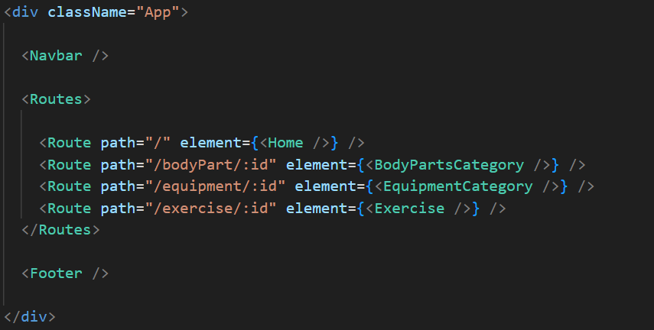

* Develop the Navbar and Hero components
* Code the popular search/categories components and fetch the categories from ***rapid Api***.
* Additionally, we can add the component to subscribe for the newsletter and the footer.
* Now, develop the category page to display various exercises under the category.
* Finally, code the exercise page, where the instructions, other details along with related videos from the YouTube will be displayed.

**Important Code snips:**

* **Fetching available Equipment list & Body parts list**

From the Rapid API hub, we fetch available equipment and list of body parts with an API request.

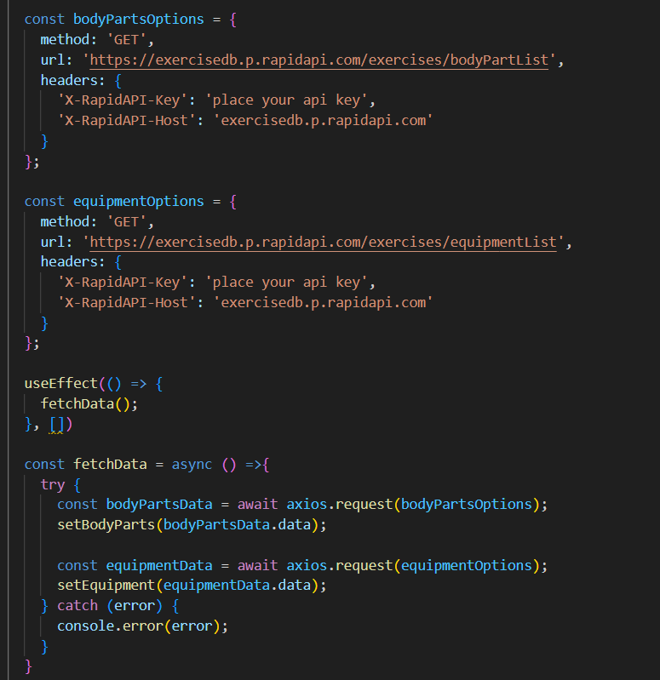

Here's a breakdown of the code:

***Dependencies****:*

The code utilizes the following libraries:

Axios: A popular promise-based HTTP client for JavaScript. You can add a link to the official documentation for Axios <https://axios-http.com/>

**API Key:**

Replace 'place your api key' with a placeholder mentioning that the user needs to replace it with their own Rapid API key. You can mention how to acquire an API key from Rapid API.

*Body Parts Options and equipment Options:*

These variables hold configuration options for fetching data from the RapidAPI exercise database.

* *method:* The HTTP method used in the request. In this case, it's set to GET as the code is fetching data from the API.
* *url:* The URL of the API endpoint to fetch data from. Here, it's set to https://exercisedb.p.rapidapi.com/exercises/bodyPartList for fetching a list of body parts and https://exercisedb.p.rapidapi.com/exercises/equipmentList for fetching a list of equipment.
* *headers:* This section contains headers required for making the API request. Here it includes the X-RapidAPI-Key header to provide your API key and the X-RapidAPI-Host header specifying the host of the API.

**fetchData function:**

This function is responsible for fetching data from the API. It makes use of async/await syntax to handle asynchronous operations. First it fetches data for body parts using axios.request(bodyPartsOptions). Then it stores the fetched data in the bodyParts state variable using setBodyParts.

Similarly, it fetches data for equipment using axios.request(equipmentOptions). Then it stores the fetched data in the equipment state variable using setEquipment. In case of any errors during the API request, the catch block logs the error to the console using console.error.

**useEffect Hook:**

The useEffect hook is used to call the fetchData function whenever the component mounts. This ensures that the data is fetched as soon as the component loads.

Overall, the code snippet demonstrates how to fetch data from a RapidAPI exercise database using JavaScript's Axios library.

* **Fetching exercises under particular category**

To fetch the exercises under a particular category, we use the below code.

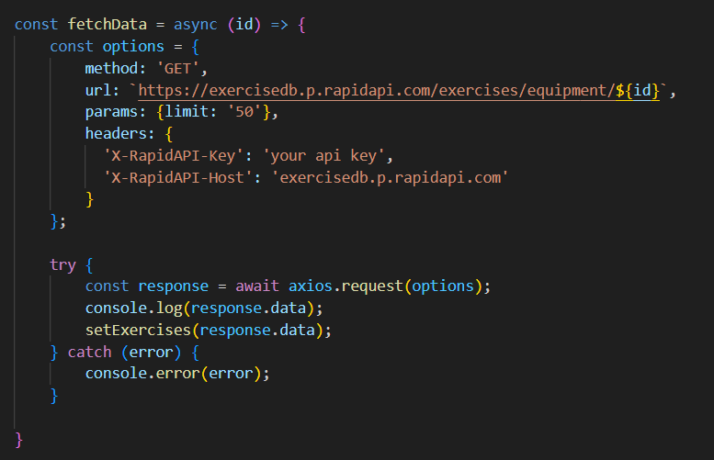

It defines a function called fetchData that fetches data from an exercise database API. Here's a breakdown of the code:

*const options = {...}:*

This line creates a constant variable named options and assigns it an object literal. The object literal contains properties that configure the API request, including:

* method: Set to 'GET', indicating that the API request is a GET request to retrieve data from the server.
* url: Set to https://exercisedb.p.rapidapi.com/exercises/equipment/${id}, which is the URL of the API endpoint for fetching exercise equipment data. The ${id} placeholder will likely be replaced with a specific equipment ID when the function is called.
* params: An object literal with a property limit: '50'. This specifies that you want to retrieve a maximum of 50 exercise equipment results.
* headers: An object literal containing two headers required for making the API request:
* 'X-RapidAPI-Key': Your RapidAPI key, which is used for authentication. You should replace 'your api key' with a placeholder instructing users to replace it with their own API key.
* 'X-RapidAPI-Host': The host of the API, which is 'exercisedb.p.rapidapi.com' in this case.

*const fetchData = async (id) => {...}:*

This line defines an asynchronous function named fetchData that takes an id parameter. This id parameter is likely used to specify the equipment ID for which data needs to be fetched from the API.

*try...catch block:*

* The try...catch block is used to handle the API request.
* The try block contains the code that attempts to fetch data from the API using axios.request(options).
* The await keyword is used before axios.request(options) because the function is asynchronous and waits for the API request to complete before proceeding.
* If the API request is successful, the response data is stored in the response constant variable.
* The console.log(response own in the image) is likely used to process the fetched data after a successful API request.
* The catch block handles any errors that might occur during the API request. If there's an error, it's logged to the console using console .error(error).

* **Fetching Exercise details**

Now, with the help of the Exercise ID, we fetch the details of a particular exercise with API request.

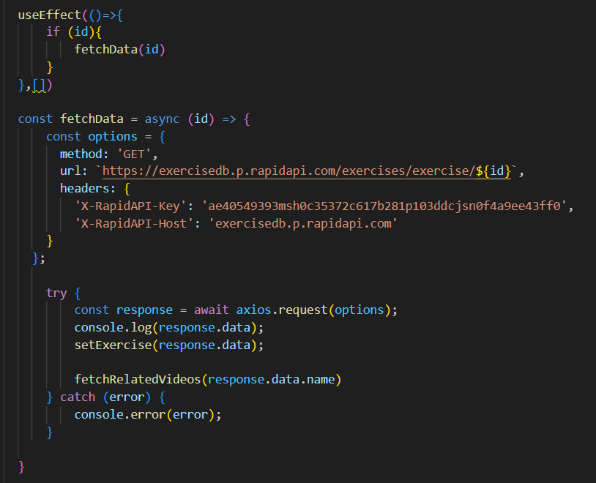

The code snippet demonstrates how to fetch exercise data from an exercise database API using JavaScript's fetch API. Here's a breakdown of the code:

***API Endpoint and Key:***

* Replace 'https://example.com/exercise' with the actual URL of the API endpoint you want to use.
* Replace 'YOUR_API_KEY' with a placeholder instructing users to replace it with their own API key obtained from the API provider.

**async function:**

The code defines an asynchronous function named fetchData that likely takes an id parameter as input. This id parameter might be used to specify the ID of a particular exercise or category of exercises to fetch.

**fetch request:**

Inside the fetchData function, the fetch API is used to make an HTTP GET request to the API endpoint. The function creates a fetch request with the following details:

* Method: GET (to retrieve data from the server)
* URL: The API endpoint URL where exercise data resides.

**Handling the Response:**

* The then method is used to handle the response from the API request. If the request is successful (i.e., status code is 200), the response is converted to JSON format using response.json().
* The .then method then likely processes the fetched exercise data, which might involve storing it in a state variable or using it to populate a user interface.

*Error Handling:*

The .catch method is used to handle any errors that might occur during the API request. If there's an error, it's logged to the console using console.error.

* **Fetching related videos from YouTube**

Now, with the API, we also fetch the videos related to a particular exercise with code given below.

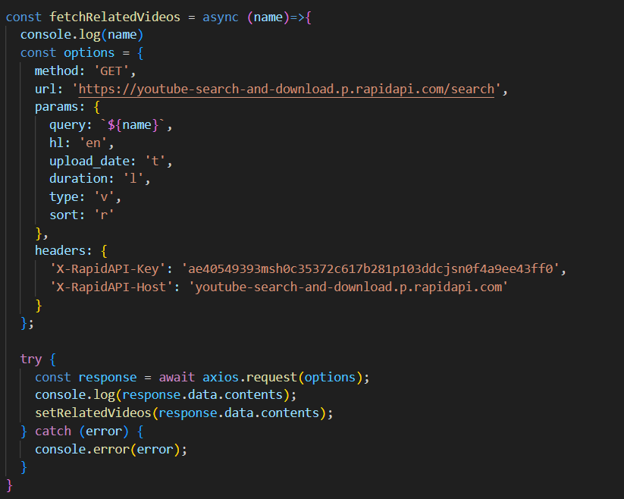

The code snippet shows a function called *fetchRelatedVideos* that fetches data from YouTube using the RapidAPI service. Here's a breakdown of the code:

**fetchRelatedVideos function:**

This function takes a name parameter as input, which is likely the name of a video or a search query.

**API configuration:**

The code creates a constant variable named options and assigns it an object literal containing configuration details for the API request:

* method: Set to 'GET', indicating a GET request to retrieve data from the server.
* url: Set to 'https://youtube-search-and-download.p.rapidapi.com/search', which is the base URL of the RapidAPI endpoint for YouTube search.
* params: An object literal containing parameters for the YouTube search query:
* query: Set to \${name}, a template literal that likely gets replaced with the actual name argument passed to the function at runtime. This specifies the search query for YouTube videos.
* Other parameters like hl (language), sort (sorting criteria), and type (video type) are included but their values are not shown in the snippet.
* headers: An object literal containing headers required for making the API request:
* 'X-RapidAPI-Key': Your RapidAPI key, which is used for authentication. You should replace 'YOUR_API_KEY' with a placeholder instructing users to replace it with their own API key.
* 'X-RapidAPI-Host': The host of the API, which is 'youtube-search-and-download.p.rapidapi.com' in this case.

**Fetching Data (try...catch block):**

* The try...catch block is used to handle the API request.
* The try block contains the code that attempts to fetch data from the API using axios.request(options).
* axios is an external JavaScript library for making HTTP requests. If you don't already use Axios in your project, you'll need to install it using a package manager like npm or yarn.
* The .then method (not shown in the code snippet) is likely used to process the fetched data after a successful API request.
* The catch block handles any errors that might occur during the API request. If there's an error, it's logged to the console using console.error(error).

**USER INTERFACE:**

• **Design Style**: Minimal, clean, and motivating.

• **Color Palette**: Energetic tones (blue, green, orange) to encourage activity.

• **Layout**: Grid-based dashboard with quick navigation.

• **UI Elements**:

* Cards for workouts/nutrition.
* Progress bars & charts.
* Motivational badges & achievements.

**STYLING**:

• **Mobile/Web**: Tailwind CSS / Material UI.

• **Animations**: Framer Motion for smooth transitions.

• **Typography**: Bold headers, readable content fonts.

**TESTING**:

After completing the code, run the react application by using the command “npm start” or “npm run dev” if you are using vite.js

Here are some of the screenshots of the application.

* **Hero component**

this section would showcase trending workouts or fitness challenges to grab users' attention.

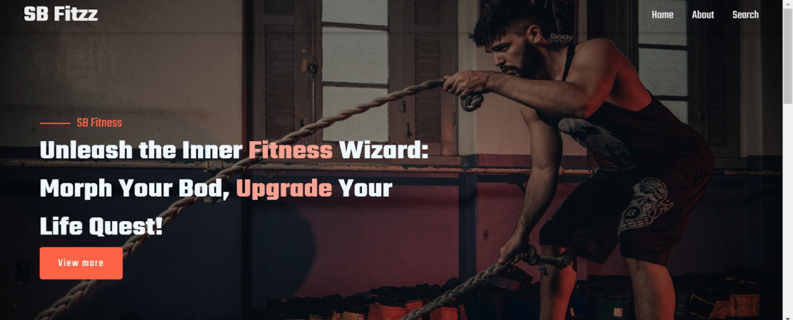

* **About**

FitFlex isn't just another fitness app. We're meticulously designed to transform your workout experience, no matter your fitness background or goals.

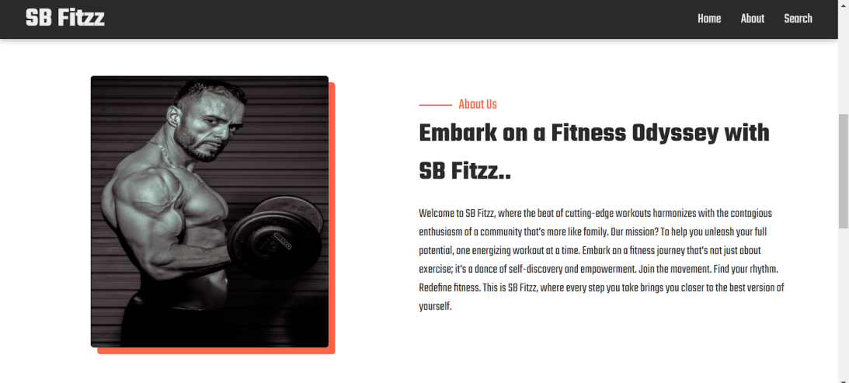

* **Search**

B Fitzz makes finding your perfect workout effortless. Our prominent search bar empowers you to explore exercises by keyword, targeted muscle group, fitness level, equipment needs, or any other relevant criteria you have in mind.  Simply type in your search term and let FitFlex guide you to the ideal workout for your goals.

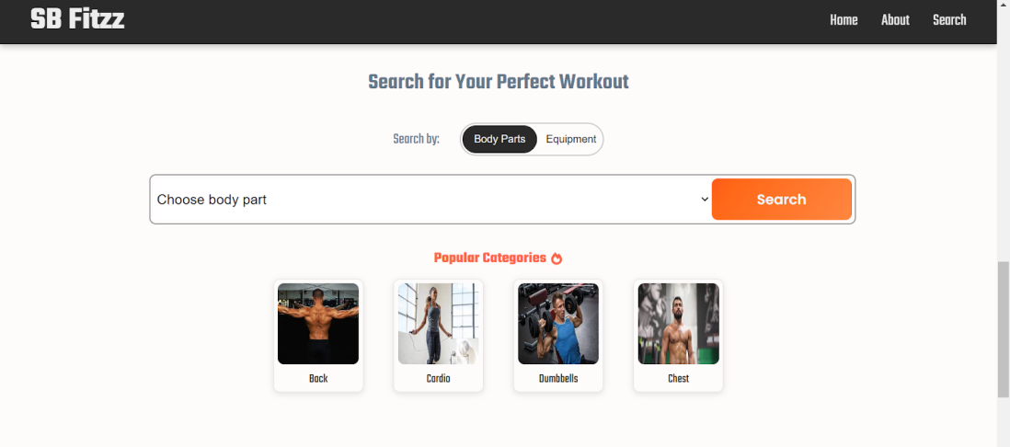

* **Category page**

FitFlex would offer a dedicated section for browsing various workout categories. This could be a grid layout with tiles showcasing different exercise types (e.g., cardio, strength training, yoga) with icons or short descriptions for easy identification.

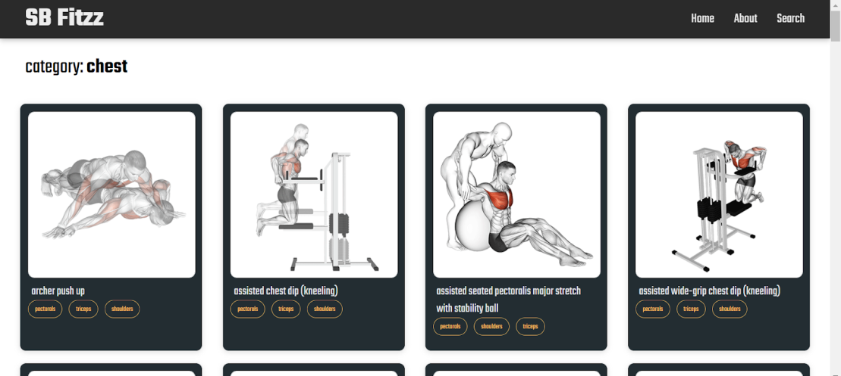

* **Exercise page**

This is where the magic happens!  Each exercise page on FitFlex provides a comprehensive overview of the chosen workout.  Expect clear and concise instructions, accompanied by high-quality visuals like photos or videos demonstrating proper form.  Additional details like targeted muscle groups, difficulty level, and equipment requirements (if any) will ensure you have all the information needed for a safe and effective workout.

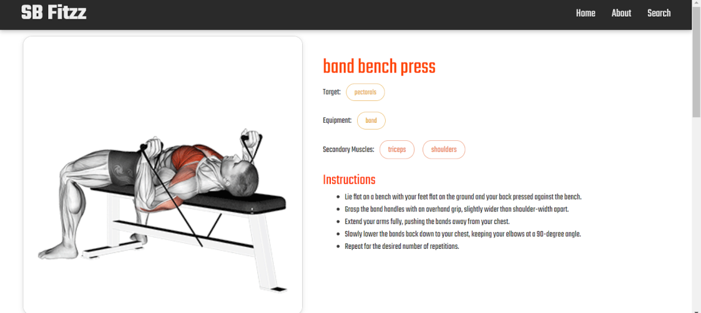

**SCREENSHOTE OR DEMO:**

<https://drive.google.com/file/d/1xbzVoqxeJRnvsh0FWv5D16EOANfwZ8U8/view?usp=sharing>

## ****Known Issues (Potential Challenges)****

* Accuracy of calorie/nutrition tracking (depends on user input).
* Integration issues with third-party wearables/APIs.
* Internet dependency for cloud sync.
* Data privacy concerns (requires strong security).
* Motivation drop-off if users don’t engage consistently

## ****Future Enhancements****

* AI-powered **voice fitness coach**.
* **AR/VR workouts** for immersive training.
* Smartwatch standalone support.
* Gamification with **fitness rewards & badges**.